# **Sennheiser Hearing Test**

**Sennheiser Hearing Test** is a mobile app developed by Sennheiser, designed for users to easily assess their hearing ability from home. It combines Sennheiser’s audio expertise with a user-friendly interface for a streamlined hearing health check. It excels in design simplicity and visual clarity, there are opportunities to enhance user experience by streamlining button descriptions and improving the calibration process.

**UI:**

* Features a clean and straightforward design, with easy navigation and large, readable text.
* Uses a simple yet impactful theme color scheme
* Designed to cater to all age groups, with a focus on simplicity and usability.
* User-friendly buttons allow for intuitive interactions based on the user's hearing experience.

**UX:**

* Displays result in an easily understandable format for straightforward interpretation of hearing abilities.
* Features inclusive design with large, readable text and simple navigation, suitable for users of all ages.
* Offers step-by-step instructions and support to help users navigate the hearing test process confidently.
* Enables users to calibrate sound levels and adjust settings to their hearing range, improving test accuracy.
* Provides useful information and tips on hearing health, aiding users in understanding and managing their hearing.
* Recommends Sennheiser products based on the user's hearing profile, enhancing the audio experience and facilitating customer support.

**Pros:**

* Simple and fast hearing test with clear results.
* Integration with Sennheiser’s audio products for a tailored audio experience.
* Clean, minimalist design that enhances usability.

**Cons:**

* Limited to basic hearing test functionality; lacks advanced features like personalized hearing programs or community support.
* May prioritize promoting Sennheiser products over other hearing solutions.
* Does not provide in-depth analysis or support beyond the initial test.

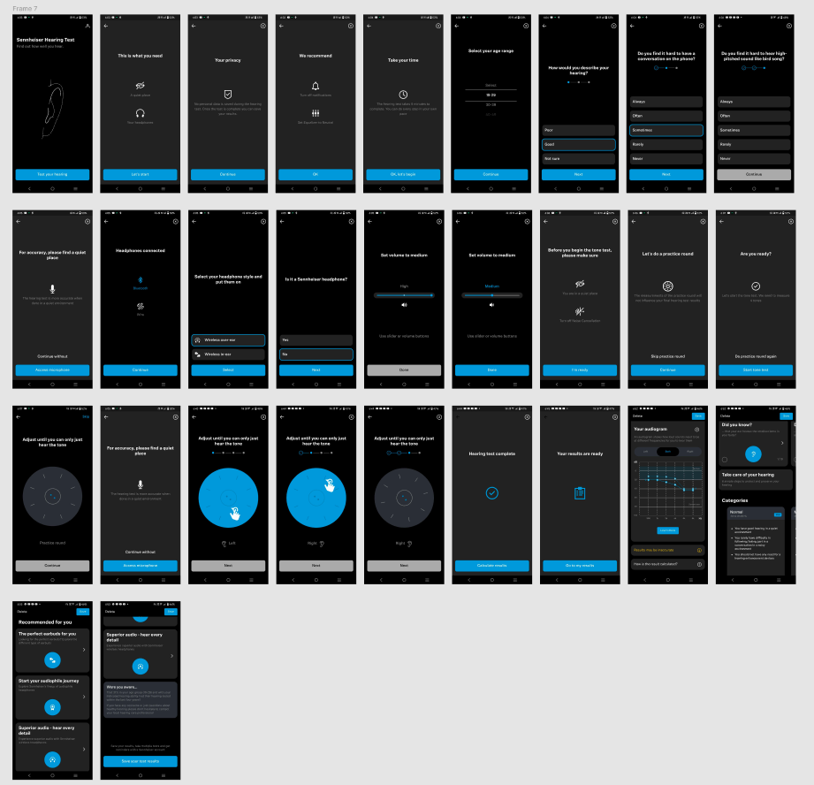

# **AmiHear**

* AmiHear is a mobile app designed to assist people with hearing difficulties by offering hearing tests, sound amplification, and personalized hearing programs. Here are some details about its features:

**UI**:

* The theme color choices do not complement the overall design; the use of very light colors may affect visual clarity.
* The font style is too thin, which can impact readability, especially when viewing from a distance.
* Border shadow is too much;

**UX:**

* Provides a straightforward hearing test experience, designed to be quick and easy for users.
* Presents test results in a clear, understandable format, making it easy for users to interpret their hearing status.
* Includes step-by-step instructions and helpful prompts throughout the hearing test, ensuring users understand each stage of the process.
* It provides manual input form for users who have known their hearing loss dBHL.

**Pros:**

* Comprehensive testing and personalization.
* Effective sound amplification and noise reduction.
* Integration with hearing aids and progress tracking.
* Straight-forward apps provide fewer screens to take the hearing test.

**Cons:**

* Requires initial setup time for personalized settings.
* Advanced features may be behind a paywall or subscription.

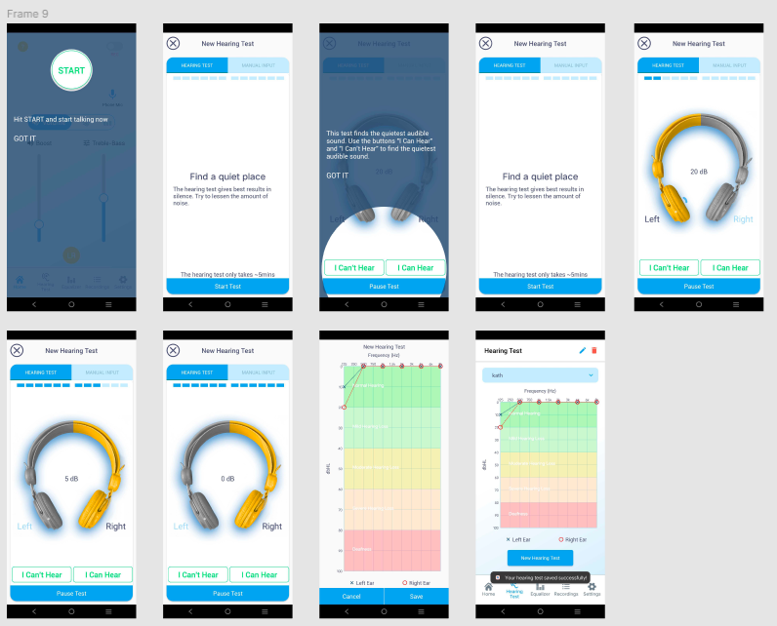

# **AudioCardio**

**AudioCardio** is a mobile app designed to help users maintain and improve their hearing health through personalized sound therapy. The app is based on the concept of sound conditioning, which involves delivering barely audible sound frequencies to stimulate and strengthen the auditory system over time.

### **UI:**

* Clean, simple layout that facilitates easy navigation through the app's features.
* Uses a clear font and layout to ensure text is easily readable.
* Provides visual representations of progress, making it easy for users to track improvements over time.
* Allows users to adjust settings and preferences, enhancing the overall user experience.

### **UX:**

* Tailors sound therapy programs based on individual hearing profiles, making the therapy more effective.
* Encourages regular use with reminders and progress tracking, helping users stay motivated and on track with their hearing health goals.
* Offers valuable information on hearing health and sound therapy, aiding users in understanding and managing their hearing better.
* Includes options for larger text and voice commands to support users with varying levels of hearing ability and enhance overall accessibility.

### **Pros and Cons:**

* **Pros:**
  + Personalized sound therapy based on individual hearing profiles.
  + Proven technology (Threshold Sound Conditioning) designed to improve hearing sensitivity.
  + Compatible with a wide range of headphones and hearing aids.
  + Engaging daily training and progress tracking to motivate users.
* **Cons:**
  + Requires regular use to see significant benefits, which may not suit all users.
  + Some features and advanced options might be available only with a **subscription**.
  + Results can vary based on the user’s hearing condition and consistency in using the app.

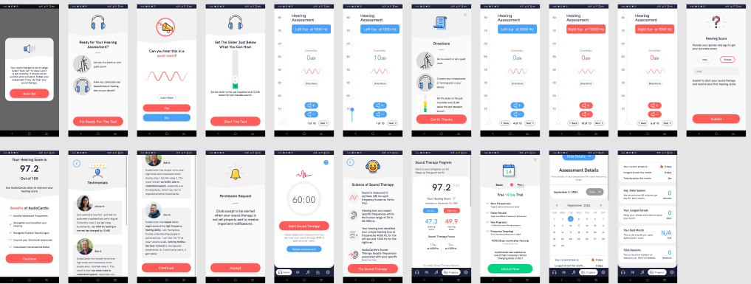

# **Hearing Test**

**HearingTest by audiologia.pl** is a mobile app developed by Audiologia.pl, a Polish platform dedicated to hearing health. The app is designed to help users quickly and conveniently check their hearing ability using various types of tests and assessments. It focuses on delivering a reliable hearing evaluation that can be done at home, making it a useful tool for people who suspect they may have hearing difficulties.

**UI:**

* Features a simple and intuitive layout, but the lengthy descriptions on buttons could be streamlined for a cleaner look.
* Uses a well-chosen color palette that enhances text clarity and overall readability, contributing to a visually appealing design.
* The calibration test page involves multiple button presses, which can be tiring. Reducing the number of presses needed would enhance the user experience.

**UX:**

* Incorporates a calibration feature to ensure accurate sound levels tailored to the user’s headphones or earbuds, mimicking professional audiological settings.
* Available in multiple languages, making it accessible to a diverse audience and allowing users to take tests and view results in their preferred language.
* Enables users to perform tests without an internet connection, storing results locally on the device for easy access at any time.
* Ensures user data privacy and security, adhering to data protection regulations. Users have control over their data and can delete it if desired.
* Offers a variety of hearing tests, including pure-tone audiometry, speech-in-noise, and high-frequency tests, providing a thorough assessment of different hearing aspects.
* Provides fundamental information on hearing health, causes of hearing loss, and tips for maintaining good hearing, enhancing the user's understanding of hearing issues.

### **Pros and Cons:**

* **Pros:**
  + Offers a variety of hearing tests to comprehensively assess different aspects of hearing.
  + Easy-to-understand results with calibration for accuracy.
  + Multilingual support and offline testing capabilities.
  + Simple, user-friendly interface suitable for all age groups.
* **Cons:**
  + Limited to basic testing and lacks advanced features like personalized hearing programs or sound amplification.
  + Minimal educational content and no community support or engagement features.
  + No integration with hearing aids or real-time hearing assistance tools.

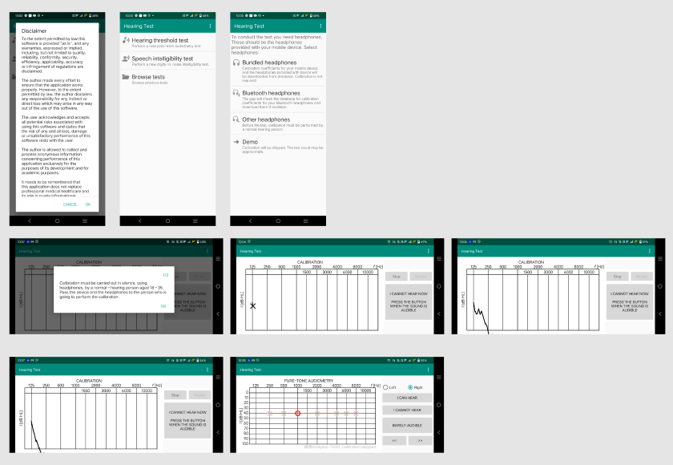

Please note that you can view the app’s screens on the Figma link for a clearer visual representation.

Click >> [here](https://www.figma.com/board/dy8HomB5Xg7VWDE0p2EwTY/Figma-Jam?node-id=0-1&t=SsygMYyXt6xY03k7-1)